Citizens for a Historic Westbank

Over 1600 voters say, “We want our town back”

Why not? PROTECT – PRESERVE - PROMOTE
November 10, 2009 - Formal Submission to District of West Kelowna - Planning Department
ATTENTION: NANCY HENDERSON
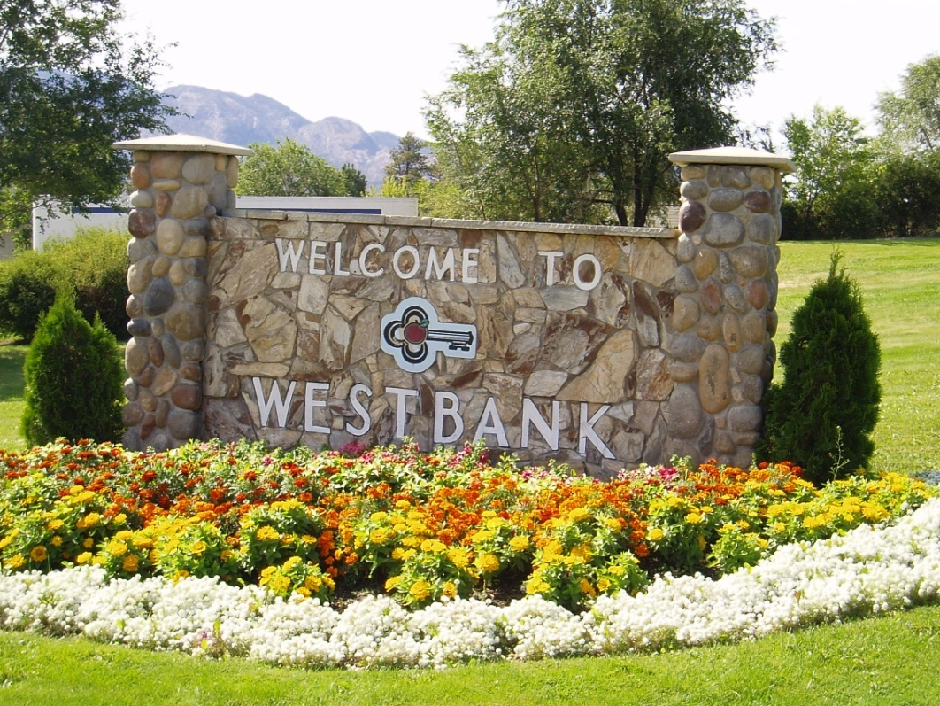
WELCOME TO WESTBANK
The Chamber “Key” symbolizes the fact that Westbank is the first Okanagan community reached by those travelling from the west over the Okanagan Connector. We are the “Key” that unlocks the door to the Okanagan. If you look at the “key” itself, you will note that its colours are primarily black with white trim. The “black” denotes the highway with the “white’ representing the centre line. The configurations of a “Cloverleaf” at the large end of the “Key” narrowing down to the “Finger” of the “Key” which represents the road to Westbank. The gold trim is a symbol of the warmth and beauty of our community and the apple of our heritage.
Westbank and District Chamber of Commerce
Recently, The proposed Westbank Town Centre Plan was referred to as the core of the community of Westbank. We would like to expand that thought to the more accurate description; that Westbank is the apple of our community; the whole apple.
FAILURE TO RECOGNIZE THE TOWN OF WESTBANK
PROPOSED CD LAND USE ZONE – WESTBANK TOWN CENTRE PLAN
- Is only a land use plan
- Allows for much higher density than existing RDCO – OCP
- RDCO intended this to be a revitalization plan for the town of Westbank – when Westbank was considered the representative town for the V4T area/Electoral Area Westbank. It was not intended to restructure the whole town into a few blocks of high rise development either side of the couplet.
- Excludes many of Westbank’s traditional landmarks:
- Westbank Yacht Club
- Gellatly Nut Farm
- Gellatly Bay Area – original Westbank Fruit Warehouse area.
- Westbank Rotary Park
- Westbank Docks
- Current location of the Westbank Museum
- Gorman’s Mill
- Westbank Cemetery
- Johnson Bentley Pool
- Is established around a couplet system that has already proven fatal
for the town of Westbank.
- V4T area residents were not be asked if they wanted to give up their town in return for a high-density, commercial development zone.
Westbank has been the home town to generations from all the communities of Glenrosa, Shannon Lake, Gellatly, Green Bay, Westbank, and later, Smith Creek and Mission Hill.
- Westbank so represented all these areas that it never really defined an area for itself, which is why the district planners are now having such difficulty establishing a boundary for the “neighborhood” of Westbank.
- Westbank is recognized internationallyon all maps.
- These communities share the Westbank, BC V4T mailing address and postal code as a designation of the unincorporated town in British Columbia.
- These communities shared an electoral area: Electoral Area (H) Westbank.
- Westbank represented the business, civic, and cultural centre of all the residents of the V4T area.
- The root and branch system of the town of Westbank reached far into
- every neighborhood in the V4T area, and in turn, they reached back individual, and yet, one and the same.
The Early Days - by Irene [Wingerter] Morrison
“We did everything together as a community, adults and children both, and we felt very much like a community even though we were part of Westbank."
a bit of Okanagan history - by Dorothy Gellatly pg. 202
“ the winery is located a few miles south of Kelowna in picturesque Westbank”
Anthony VonMandl’s goal for Mission Hill Winery - “Our goal is to embark on an ambitious program using the unique Westbank, BC facility.”

http://www.winesofcanada.com/towns.html
“Located Across the lake from Kelowna is the established town of Westbank.
It is a tourist and residential community with numerous orchards and vineyards.”

THE TOWN OF WESTBANK
- Westbank and its neighborhoods created their own individual town and community. They have never been part of Kelowna.

- Westbank developed its own Board of Trade in 1939 – now known as the Westbank and District Chamber of Commerce. Even today, the Chamber board has to admit that is represents a mixture of Peachland, Westbank First Nation, and it umbrellas the whole V4T area of Westbank businesses.

- Westbank developed its own community service groups: Westbank Lion’s Club, Westbank Rotary, and Westbank Kinsmen, Westbank Legion, Westbank Boys and Girls Club. These service organizations represented the whole V4T area. The other communities outside of the V4T area either joined the Westbank groups or they traveled to Kelowna and volunteered in Kelown’a service organizations.

- Westbank has been the anchor for everything to do with the development, growth, promotion, and identity of the V4T area. Churches, schools, offices, businesses, residences.

- It is the heart and soul of the community.

TAKING THE HISTORY AND THE PRESENT AND CREATING OUR FUTURE
WESTBANK’S FUTURE ROLE IN THE DISTRICT OF WEST KELOWNA
- We have always maintained that Westbank, BC V4T can play a vibrant role in the district’s future, but not at the expense of losing the town; only with the recognition of the town.
Recently, at the Stakeholder Committee Meeting at the Cove Resort on October, 29, 2009, Paul Fenske of Ekistics Consulting took us on a guided tour from the southern Coquilhala Interchange – north to the bridge capturing the significance, importance, and potential that Westbank has to offer the District.
We would like to reverse the tour and travel from the bridge to the Connector - north to south. Traveling south from the District of West Kelowna’s gateway at Boucherie and Highway 97.

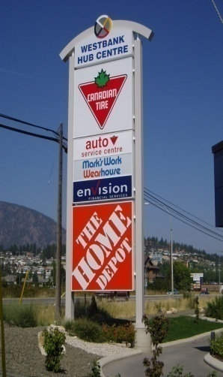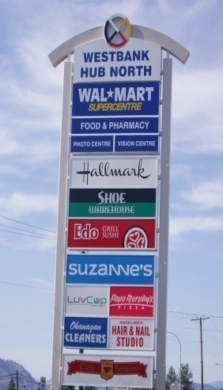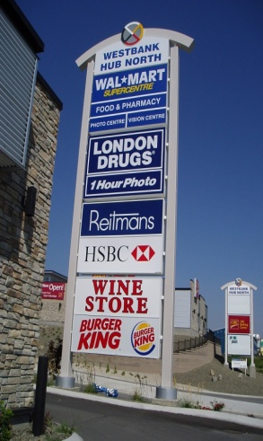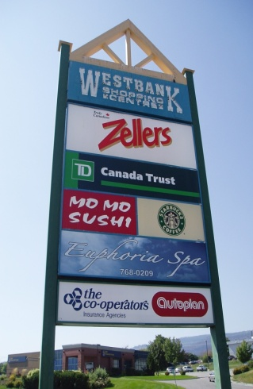

The visual impact of Westbank and the Westbank First Nation Commercial Development is now irrevocable.
People working Together
There is an undeniable history of people working together to build this community. Westbank First Nation and the greater community of Westbank have done this for years. It solidified its cooperative goal in 1965 when the First Nation took on the name of Westbank to blend in and be a part of this community.
The separation of that identity between our Westbank First Nation and non-native resident neighbors and friends, school mates, and business associates is in every way opposite to the foundational principals of community building and non-racial objectives.
MAKING A SUCCESS OF WESTBANK
- Use Westbank First Nation commercial anchor, in the heart of the community, to our advantage.
- Compliment the Westbank First Nation big box development.
- Best combination for success on this southern most end of the district.
- Give the people of this southern most end of the district something that they can believe in, support, get behind, and join in to the success of the whole area.
- Taking away that identity is, once again, in every way, opposite to the foundational principals of community building.
BENEFITS OF RETAINING AND PROMOTING THE TOWN OF WESTBANK
- Avoids confusion in a community that identifies strongly with the name of their town, Westbank, BC.
- Puts to rest the community dissatisfaction surrounding the Re-Naming process and the Opinion Vote (47.92% is not a majority), and recognizes that the electorate may have supported the name of West Kelowna as the name of their district governance, they did not vote to change the name of the town of Westbank. They were never informed about the loss of their town.
- This solution satisfies both the north and south areas of the district as now they both have an identity that they are proud of, and they are willing to contribute to for the benefit of the whole district.
- Maintains the integrity of the history of the town of Westbank and the neighborhoods that call it their home town and establishes a natural boundary as it is already very much established.
- Avoids unnecessary signage changes and wasteful expense:
- Highways Department
- Maps
- Business Advertising
- Residential Addresses
- There is no cost to the district to recognize Westbank within its boundaries. There is significant cost to the district’s current strategy to re-name everything that is already established as Westbank.
- Combined with the Westbank First Nation developments, they make an effective and commercial powerhouse.
- Less confusing to motorists, tourists, and our own residents.
- Supported by the majority of the population of the V4T area.

COMPLIMENT – NOT COMPETE

Westbank can grasp the old charm of the Okanagan Valley with the ALR Lands: orchards, farms, and vegetable markets. Argi-tourism is a natural choice to promote Westbank’s contribution to the District.

- Eg: Davison Orchards http://www.davisonorchards.ca/
- BC Agri-Tourism http://www.agritourismbc.org/operators.htm

The OCP process seeks public input to draft the future direction of our community. The 1600 signatures on the petition to keep Westbank a town within the District of West Kelowna is by far the largest public directive you have received to date.
We want our town back.
We ask that you consider our positive suggestions.

